# Playlist

## Project Specification

## Rules

My project is an attempt at creating a playlist of songs through an SQL database using JDBC. Originally I wanted to integrate this into a radio type program with adverts and news/sport add-ons, but realised this was too complex early on. The hope was that I could produce a playlist of ten songs from each year of the official UK charts since 1952, and allow them to be randomly played, and to be placed in ArrayLists of differing genres.

## How the program Works

There are two Database classes, one to simply display the list of songs, and the other which I used to use SQL query statements. An example is being able to persist a song.

There is a Song class which holds all the getters and setters.

A Playlist class is for defining ArrayLists of different genres but I unfortunately didn’t have the time to do much with this.

My GUI displays a JTable of songs and has a JButton with a “Delete” function on right-click. I was unable to produce the code to populate the songs from my ArrayList and so had to hard code the songs myself. I only got 100 of the hoped 670 inside the table.

Finally, my RadioPlayer class plays the audio.

VOPC/UML Diagrams

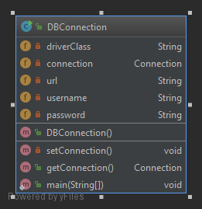

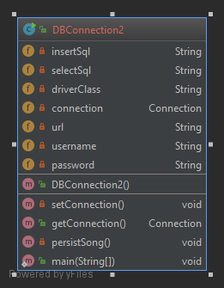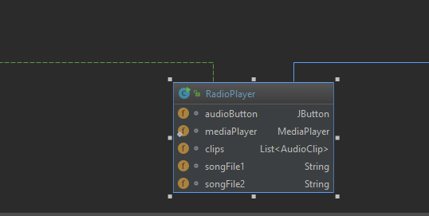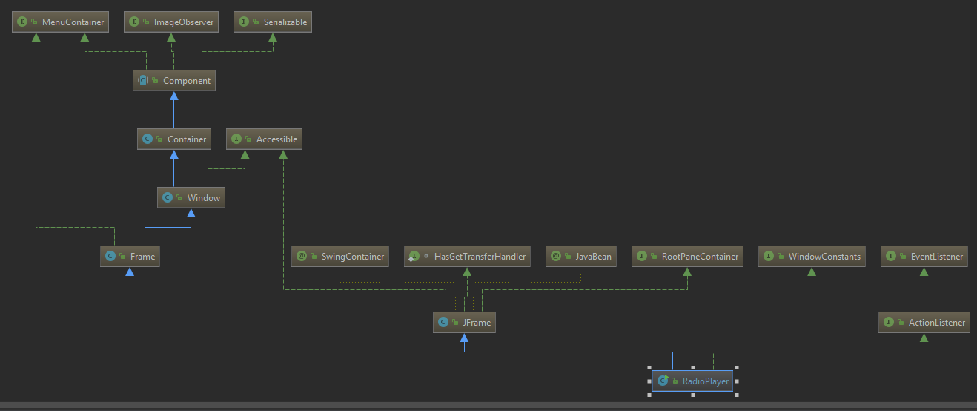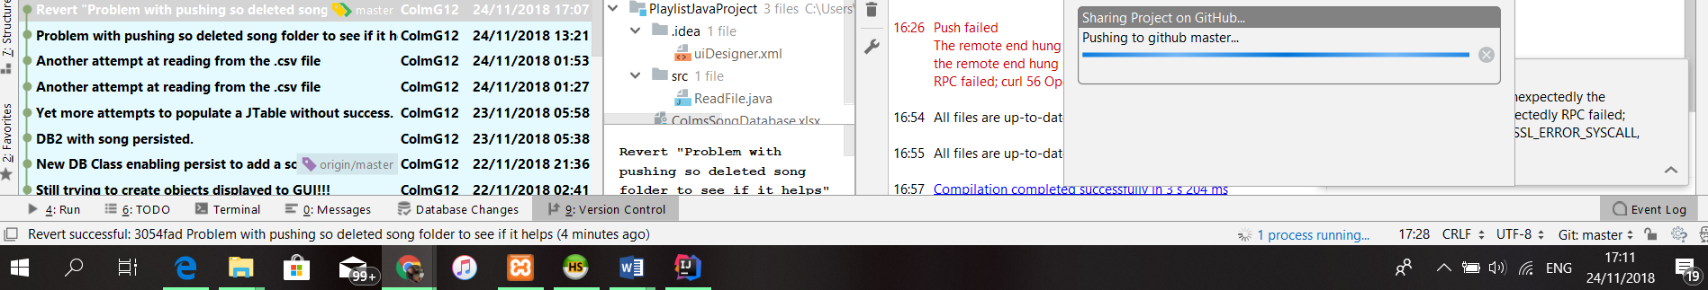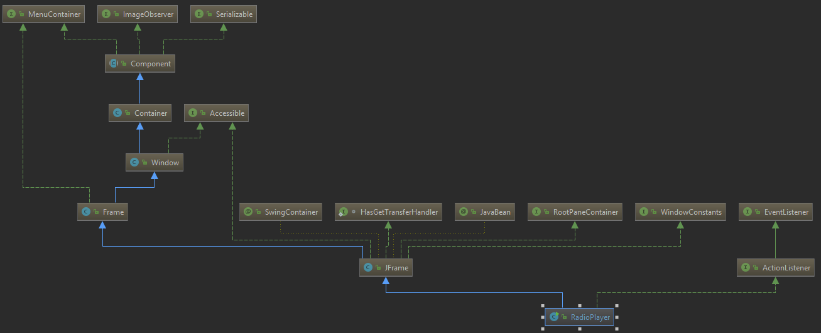

Link to Github project

<https://github.com/ColmG12/PlaylistJavaProject>

Links to Github commits

<https://github.com/ColmG12/PlaylistJavaProject/commits/master>

I had a number of errors trying to push to Github in the final few days of the project (since Thurday 22nd November). I think this may have been due to my song folder being over 5GB so I have included screenshots below to show the attempts which Github does not show itself.

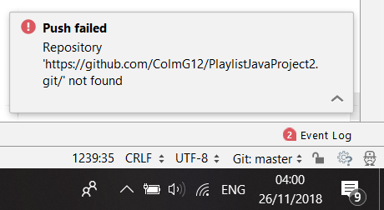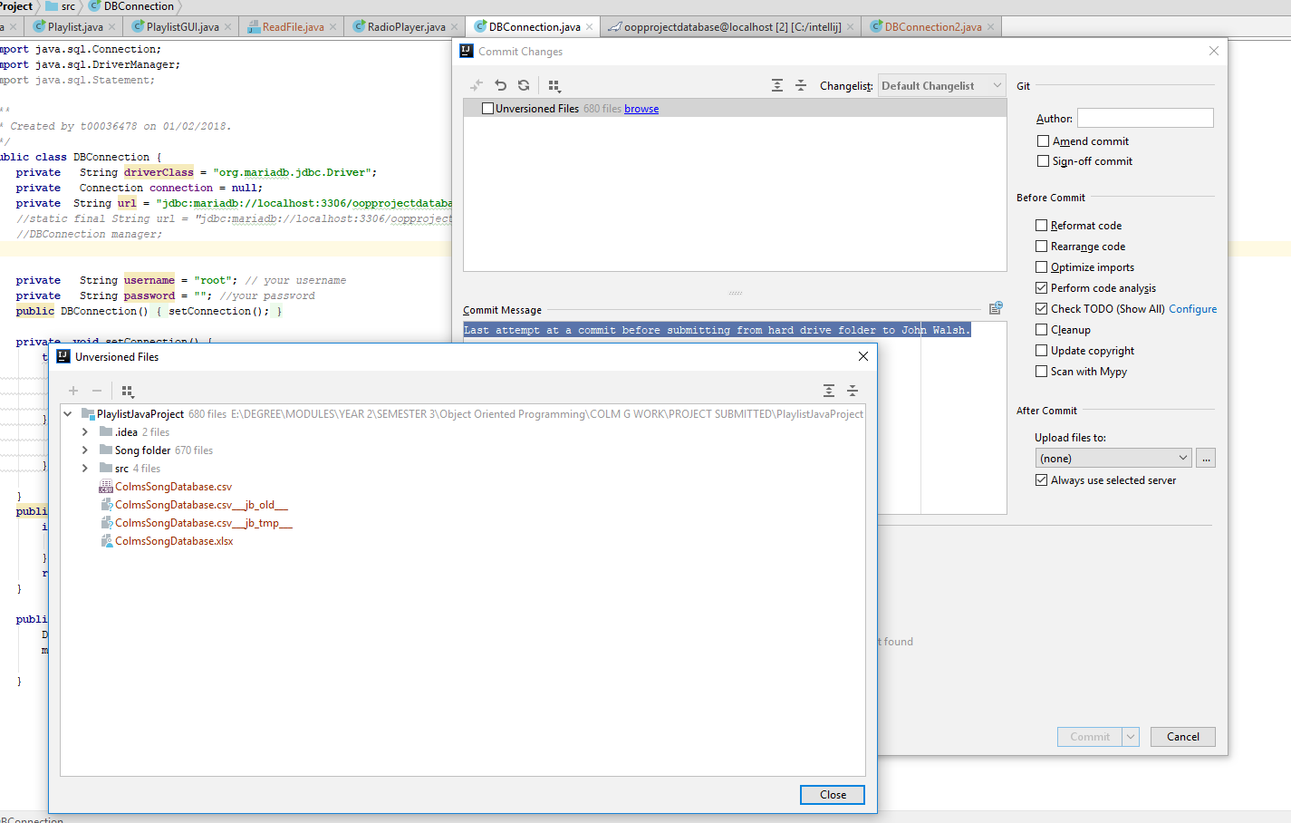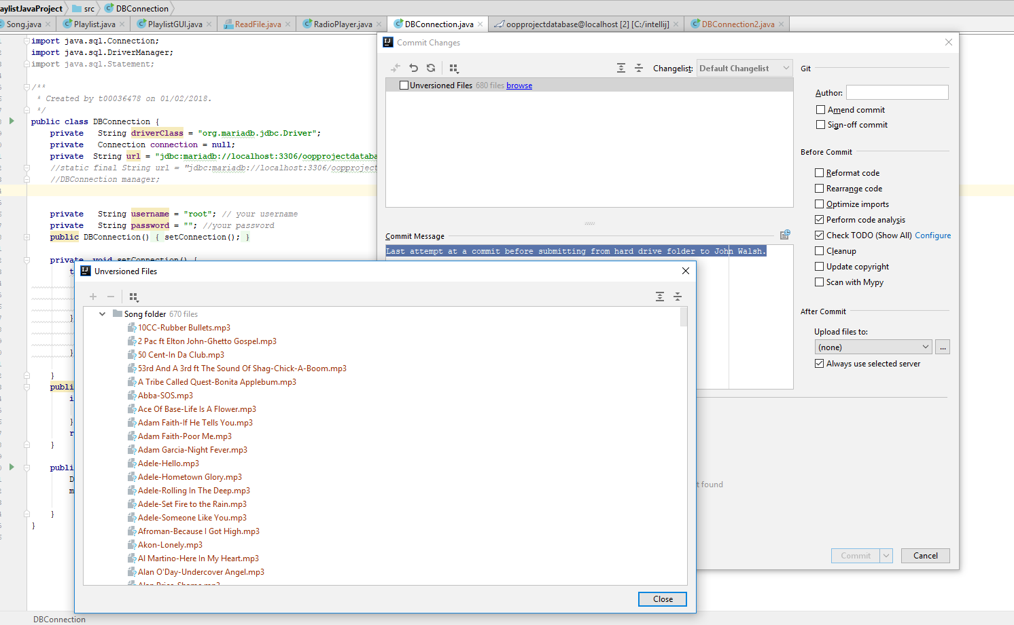

My Javadoc links are in a folder to be given up with my project.

CODE FOR REFERENCING IN OOP PROJECT Y2SEM1

//To import .csv file into HeidiSQL

<https://www.youtube.com/watch?v=n6xYjdC_lGY>

//To export .sql file from HeidiSQL

<https://www.youtube.com/watch?v=xBbqDLXrZGY>

<https://support.appliedi.net/kb/a1034/how-to-import-and-export-a-mysql-database-using-heidisql.aspx>

//Heidi help

<https://www.youtube.com/watch?v=bDR47bViIL8&list=PLYCd0fD0nZdPt-2LunKGBVDqVDuD407va&index=3>

//ColmsSongDatabase converted into .csv file by John Brosnan

//Connecting to MariaDB using Java

<https://stackoverflow.com/questions/37909487/how-can-i-connect-to-mariadb-using-java>

<https://www.tutorialspoint.com/jdbc/jdbc-sample-code.htm>

<https://www.tutorialspoint.com/intellij_idea/intellij_idea_databases.htm>

//Peter Given “Lab Week 1 JDBC”

//Peter Given “Lab Week 2 JDBC”

//MariaDB driver for Java

<https://mariadb.com/kb/en/library/about-mariadb-connector-j/>

//GUI help

<http://www.ntu.edu.sg/home/ehchua/programming/java/j4a_gui_2.html?fbclid=IwAR2fY4sa3-x5qXRmO6jAi5b5wyP5wyhTfHnNPlXKwqCwS5ff_t4mBdquw-s>

<https://www.geeksforgeeks.org/java-swing-jtable/>

//Creating Array

<https://stackoverflow.com/questions/32265533/reading-contents-of-a-file-into-class-objects>

//Importing .csv into GUI

<https://www.javainterviewpoint.com/how-to-read-and-parse-csv-file-in-java/>

<https://stackoverflow.com/questions/6411357/java-api-to-make-an-object-from-a-csv-file>

<https://stackoverflow.com/questions/44577245/java-create-object-from-csv-data-and-save-to-list>

<http://opencsv.sourceforge.net/>

<https://stackoverflow.com/questions/32265533/reading-contents-of-a-file-into-class-objects>

<https://stackoverflow.com/questions/32265533/reading-contents-of-a-file-into-class-objects>

//Creating a shuffle

<https://stackoverflow.com/questions/20487901/creating-a-shuffle-method-for-playlist-in-java>

//Creating a popup menu

<https://stackoverflow.com/questions/16743427/jtable-right-click-popup-menu/16744349>